Федеральное агентство связи

Федеральное государственное бюджетное образовательное учреждение высшего образования

«Сибирский государственный университет телекоммуникаций и информатики»

Кафедра прикладной математики и кибернетики

Отчет по лабораторной работе

по дисциплине «Визуальное программирование»

Лабораторная работа № 2

Выполнил: студент 2 курса группы ИП-811 Мироненко К. А

Проверил: доцент кафедры ПМиК Ситняковская Е. И.

Оглавление

1. Постановка задачи 3

2. Описание работы 5

3. Примеры работы программы 6

*Приложение* Листинг 9

# Постановка задачи

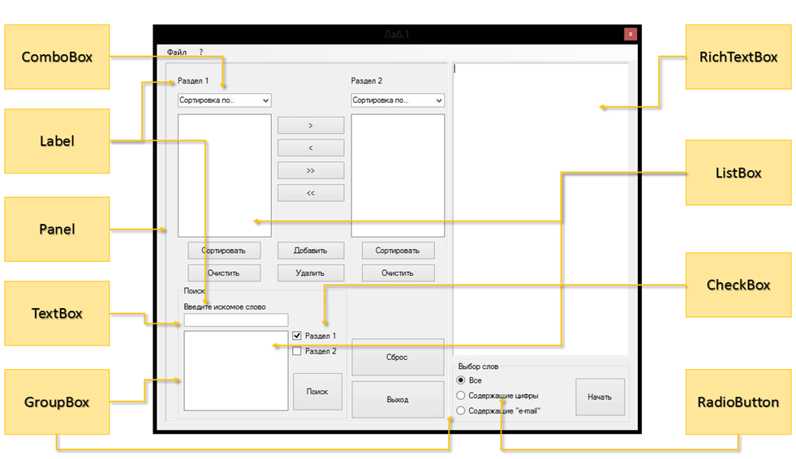

Рисунок 1.

1. Создать визуальную часть, используя необходимые компоненты. Все нужные компоненты указаны на рисунке 1. Их расположение и общий вид формы может выбираться самостоятельно.
2. Приложение должно позволить пользователю открыть текстовый файл, который считается в RichTextBox. Далее, пользователь может выбрать критерий по которому он хочет отобрать слова: «Все», «Содеражащие цифры», «Содержащие ‘e-mail’. После нажатия на кнопку «Начать», текст в RichTextBox’e разбивается на слова, которые в свою очередь, заносятся в ListBox (Раздел 1), по заданному критерию. Между двумя разделами имеется панель, в которой находятся 4 кнопки, посредством которых можно переносить отдельные выбранные слова, либо всю коллекцию из одного ListBox’a в другой, а также кнопки «Добавить» и «Удалить», которые соответственно реализуют добавление/удаление элементов из разделов. Также каждый раздел можно очистить, либо отсортировать четырьмя способами: по длине (возр.), по длине (убыв.), по алфавиту (возр.) и соответственно по алфавиту (убыв.). В нижнем правом углу находится блок, отвечающий за поиск строк в разделах. Должна быть также реализована возможность сохранения содержимого из Раздела 2 в текстовый файл.
3. Реализовать Сортировку разделов, любым известным алгоритмом сортировки самостоятельно.

# Описание работы

Работа приложения соответствует описанию в методичке, за исключением именования и свойств некоторых элементов.

# Примеры работы программы

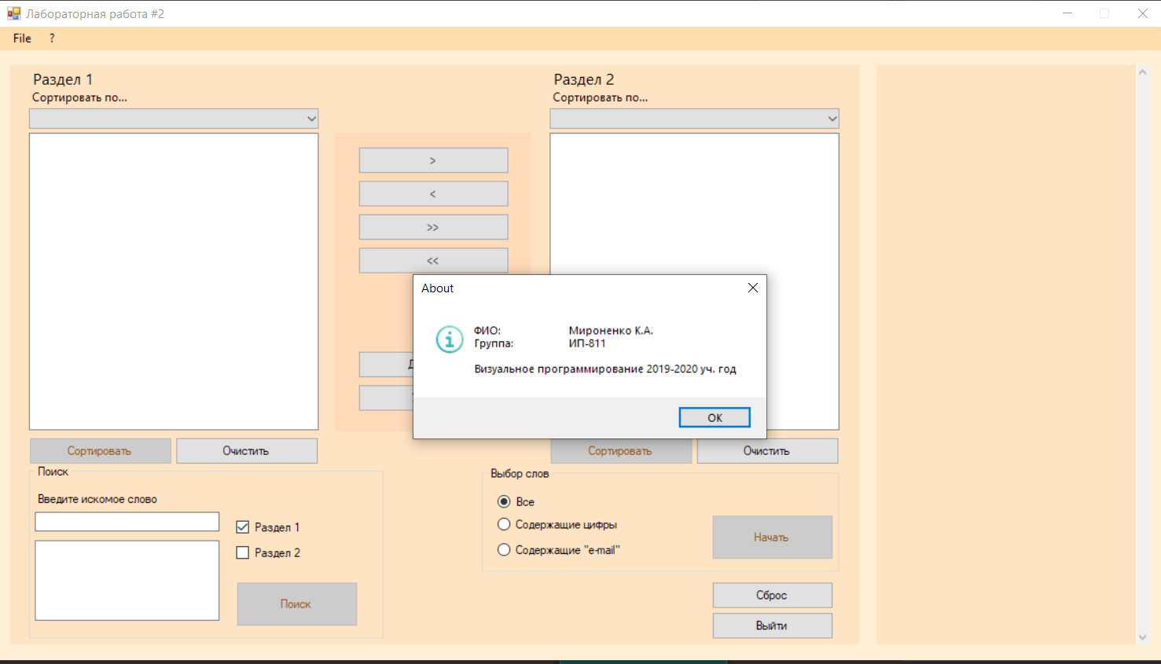

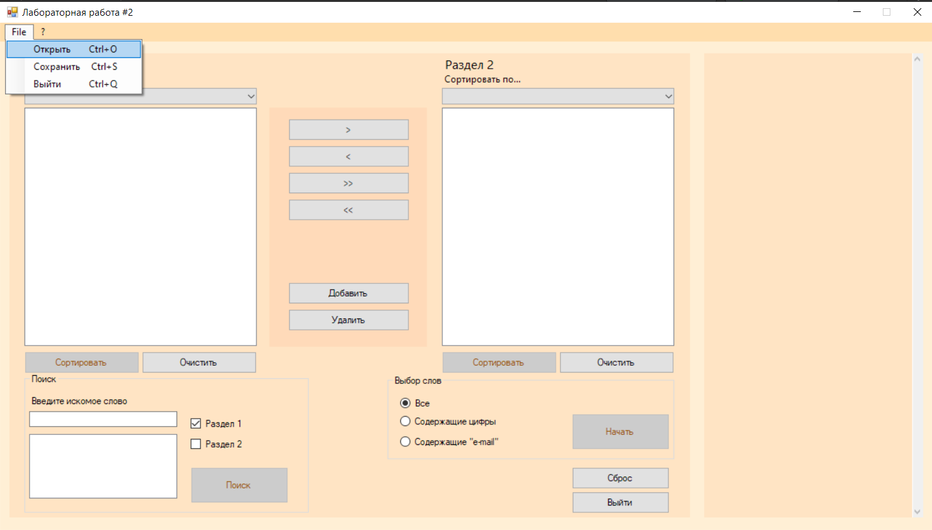

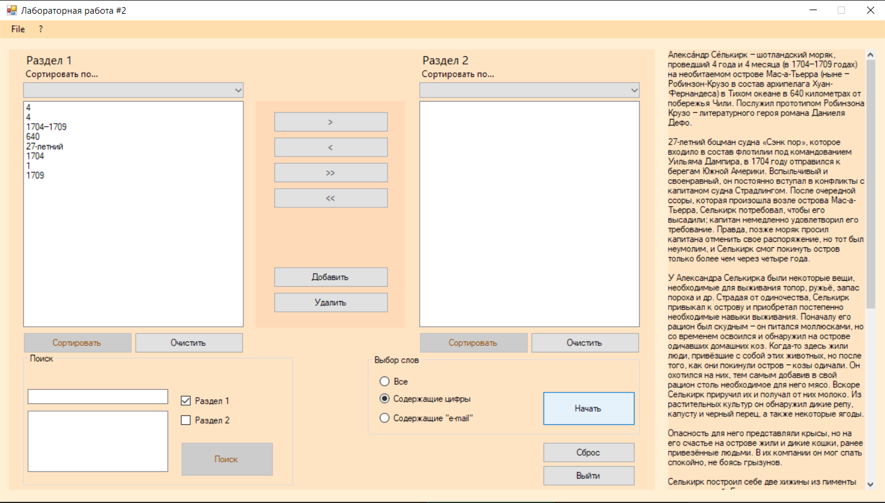

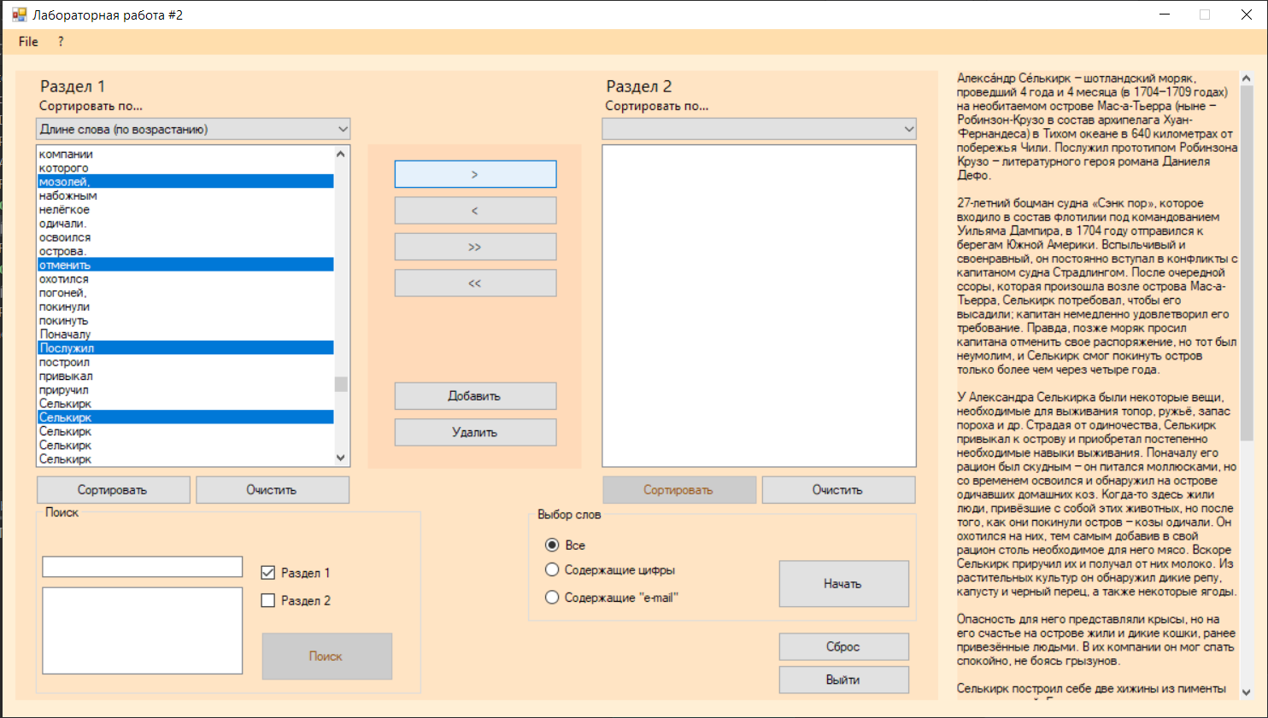

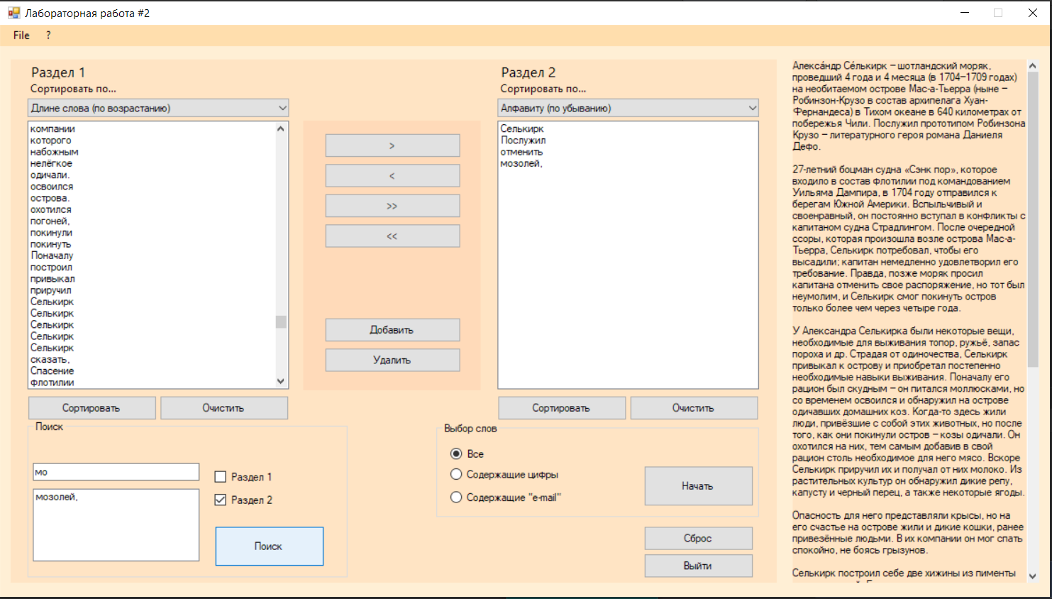

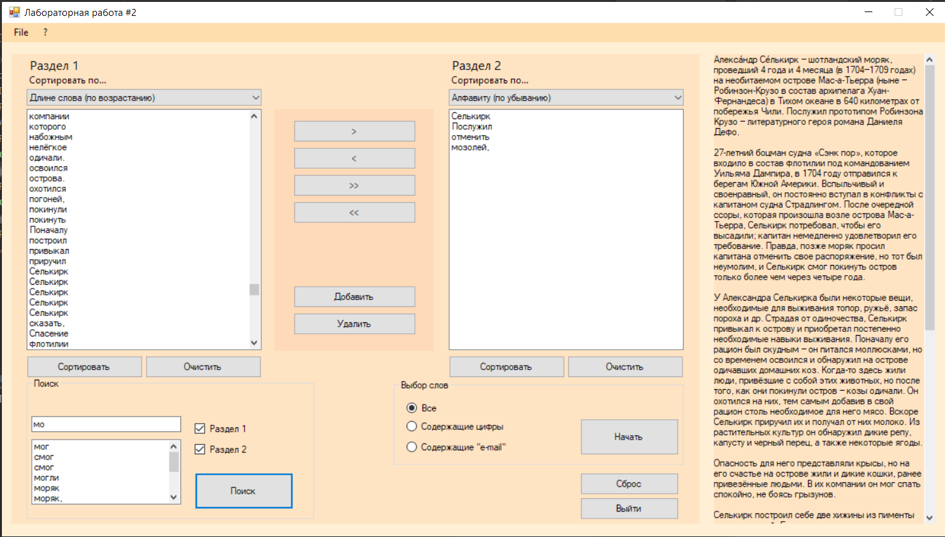

# *Приложение* Листинг

**Program.cs**

using System;

using System.Collections.Generic;

using System.Linq;

using System.Threading.Tasks;

using System.Windows.Forms;

namespace laboratoryWork_2

{

static class Program

{

/// <summary>

/// The main entry point for the application.

/// </summary>

[STAThread]

static void Main()

{

Application.EnableVisualStyles();

Application.SetCompatibleTextRenderingDefault(false);

Application.Run(new FormMain());

}

}

}

**FormMain.cs**

using System;

using System.Collections.Generic;

using System.IO;

using System.Linq;

using System.Text;

using System.Text.RegularExpressions;

using System.Windows.Forms;

namespace laboratoryWork_2

{

public partial class FormMain : Form

{

public FormMain()

{

InitializeComponent();

}

/* <MENU> */

private void openToolStripMenuItem_Click(object sender, EventArgs e)

{

OpenFileDialog openDlg = new OpenFileDialog();

if (openDlg.ShowDialog() == DialogResult.OK)

{

StreamReader reader = new StreamReader(openDlg.FileName, Encoding.Default);

textWorkSpace.Text = reader.ReadToEnd();

reader.Close();

}

openDlg.Dispose();

}

private void saveToolStripMenuItem_Click(object sender, EventArgs e)

{

SaveFileDialog saveDlg = new SaveFileDialog();

if (saveDlg.ShowDialog() == DialogResult.OK)

{

StreamWriter writer = new StreamWriter(saveDlg.FileName);

foreach (var item in listBoxSection2.Items)

writer.WriteLine((string) item);

writer.Close();

}

saveDlg.Dispose();

}

private void exitToolStripMenuItem_Click(object sender, EventArgs e)

{

Application.Exit();

}

private void aboutStripMenuItem_Click(object sender, EventArgs e)

{

MessageBox.Show(

"ФИО:\t\tМироненко К.А.\nГруппа:\t\tИП-811\n\nВизуальное программирование 2019-2020 уч. год",

"About",

MessageBoxButtons.OK,

MessageBoxIcon.Information);

}

/* < / MENU> */

/* <SECTION 1> */

private void buttonClearSection1_Click(object sender, EventArgs e)

{

listBoxSection1.Items.Clear();

}

private void comboBoxSection1_SelectedIndexChanged(object sender, EventArgs e)

{

buttonSortSection1.Enabled = comboBoxSection1.SelectedIndex != -1;

}

private void buttonSortSection1_Click(object sender, EventArgs e)

{

string[] arr = new string[listBoxSection1.Items.Count];

for (int i = 0; i < listBoxSection1.Items.Count; i++)

arr[i] = listBoxSection1.Items[i].ToString();

IEnumerable<string> res = arr.OrderBy(x => x);

switch (comboBoxSection1.SelectedIndex)

{

case 0 :

break;

case 1 :

res = res.Reverse();

break;

case 2 :

res = arr.OrderBy(x => (x.Length, x));

break;

case 3 :

res = arr.OrderBy(x => (x.Length, x)).Reverse();

break;

}

listBoxSection1.Items.Clear();

listBoxSection1.BeginUpdate();

foreach (var text in res)

listBoxSection1.Items.Add(text);

listBoxSection1.EndUpdate();

}

/* < / SECTION 1> */

/* <SECTION 2> */

private void buttonClearSection2_Click(object sender, EventArgs e)

{

listBoxSection2.Items.Clear();

}

private void comboBoxSection2_SelectedIndexChanged(object sender, EventArgs e)

{

buttonSortSection2.Enabled = comboBoxSection2.SelectedIndex != -1;

}

private void buttonSortSection2_Click(object sender, EventArgs e)

{

string[] arr = new string[listBoxSection2.Items.Count];

for (int i = 0; i < listBoxSection2.Items.Count; i++)

arr[i] = listBoxSection2.Items[i].ToString();

IEnumerable<string> res = arr.OrderBy(x => x);

switch (comboBoxSection2.SelectedIndex)

{

case 0 :

break;

case 1 :

res = res.Reverse();

break;

case 2 :

res = arr.OrderBy(x => (x.Length, x));

break;

case 3 :

res = arr.OrderBy(x => (x.Length, x)).Reverse();

break;

}

listBoxSection2.Items.Clear();

listBoxSection2.BeginUpdate();

foreach (var text in res)

listBoxSection2.Items.Add(text);

listBoxSection2.EndUpdate();

}

/* < / SECTION 2> */

/* <BUTTONS SECTION> */

private void buttonRightMove_Click(object sender, EventArgs e)

{

listBoxSection2.BeginUpdate();

foreach (object item in listBoxSection1.SelectedItems)

listBoxSection2.Items.Add(item);

listBoxSection2.EndUpdate();

delSelectedStrings(listBoxSection1);

}

private void buttonLeftMove_Click(object sender, EventArgs e)

{

listBoxSection1.BeginUpdate();

foreach (object item in listBoxSection2.SelectedItems)

listBoxSection1.Items.Add(item);

listBoxSection1.EndUpdate();

delSelectedStrings(listBoxSection2);

}

private void buttonRightAllMove_Click(object sender, EventArgs e)

{

listBoxSection1.BeginUpdate();

listBoxSection2.BeginUpdate();

listBoxSection2.Items.AddRange(listBoxSection1.Items);

listBoxSection1.Items.Clear();

listBoxSection1.EndUpdate();

listBoxSection2.EndUpdate();

}

private void buttonLeftAllMove_Click(object sender, EventArgs e)

{

listBoxSection1.BeginUpdate();

listBoxSection2.BeginUpdate();

listBoxSection1.Items.AddRange(listBoxSection2.Items);

listBoxSection2.Items.Clear();

listBoxSection1.EndUpdate();

listBoxSection2.EndUpdate();

}

public void addWordInSection(int section, string str)

{

switch (section)

{

case 1:

listBoxSection1.Items.Add(str);

break;

case 2:

listBoxSection2.Items.Add(str);

break;

}

}

private void buttonAdd_Click(object sender, EventArgs e)

{

FormAdd addForm = new FormAdd();

addForm.Owner = this;

addForm.ShowDialog();

}

private void delSelectedStrings(ListBox list)

{

list.BeginUpdate();

for (int i = list.Items.Count - 1; i > -1; i--)

if (list.GetSelected(i))

list.Items.RemoveAt(i);

list.EndUpdate();

}

private void buttonDel_Click(object sender, EventArgs e)

{

delSelectedStrings(listBoxSection1);

delSelectedStrings(listBoxSection2);

}

/* < / BUTTONS SECTION> */

/* <SEARCH SECTION> */

private void buttonSearch_Click(object sender, EventArgs e)

{

listBoxSearch.Items.Clear();

string find = textBoxWord.Text;

if (checkSection1.Checked)

{

foreach (string s in listBoxSection1.Items)

{

if (s.Contains(find)) listBoxSearch.Items.Add(s);

}

}

if (checkSection2.Checked)

{

foreach (string s in listBoxSection2.Items)

{

if (s.Contains(find)) listBoxSearch.Items.Add(s);

}

}

}

/* < / SEARCH SECTION> */

/* <WORD SELECTION SECTION> */

private void textBoxWord_TextChanged(object sender, EventArgs e)

{

buttonSearch.Enabled = textBoxWord.Text != "";

}

private void buttonStart_Click(object sender, EventArgs e)

{

listBoxSection1.Items.Clear();

listBoxSection2.Items.Clear();

listBoxSearch.Items.Clear();

labelSearch.Text = "";

listBoxSection1.BeginUpdate();

string[] strings = textWorkSpace.Text.Split(new char[] { '\n', '\t', ' ' }, StringSplitOptions.RemoveEmptyEntries);

foreach (string s in strings)

{

string str = s.Trim(); // .Trim(new char[] { ',', ';', '.', '!', '?', ':', '"', '\'' })

if (str == String.Empty) continue;

if (radioChoiceAll.Checked)

listBoxSection1.Items.Add(str);

if (radioChoiceNumbers.Checked)

if (Regex.IsMatch(str, @"\d"))

listBoxSection1.Items.Add(str);

if (radioChoiceEmail.Checked)

if (Regex.IsMatch(str, @"\w+@\w+\.\w+"))

listBoxSection1.Items.Add(str);

}

listBoxSection1.EndUpdate();

}

/* < / WORD SELECTION SECTION> */

private void buttonReset_Click(object sender, EventArgs e)

{

listBoxSection1.Items.Clear();

comboBoxSection1.SelectedIndex = -1;

listBoxSection2.Items.Clear();

comboBoxSection2.SelectedIndex = -1;

listBoxSearch.Items.Clear();

textWorkSpace.Clear();

textBoxWord.Clear();

checkSection1.Checked = true;

checkSection2.Checked = false;

radioChoiceAll.Checked = true;

}

private void buttonClose_Click(object sender, EventArgs e)

{

Application.Exit();

}

private void textWorkSpace_TextChanged(object sender, EventArgs e)

{

buttonStart.Enabled = textWorkSpace.Text != "";

}

}

}

**FormMain.Designer.cs**

using System.ComponentModel;

namespace laboratoryWork_2

{

partial class FormMain

{

/// <summary>

/// Required designer variable.

/// </summary>

private IContainer components = null;

/// <summary>

/// Clean up any resources being used.

/// </summary>

/// <param name="disposing">true if managed resources should be disposed; otherwise, false.</param>

protected override void Dispose(bool disposing)

{

if (disposing && (components != null))

{

components.Dispose();

}

base.Dispose(disposing);

}

#region Windows Form Designer generated code

/// <summary>

/// Required method for Designer support - do not modify

/// the contents of this method with the code editor.

/// </summary>

private void InitializeComponent()

{

this.menuStrip1 = new System.Windows.Forms.MenuStrip();

this.fileToolStripMenuItem = new System.Windows.Forms.ToolStripMenuItem();

this.openToolStripMenuItem = new System.Windows.Forms.ToolStripMenuItem();

this.saveToolStripMenuItem = new System.Windows.Forms.ToolStripMenuItem();

this.exitToolStripMenuItem = new System.Windows.Forms.ToolStripMenuItem();

this.aboutStripMenuItem = new System.Windows.Forms.ToolStripMenuItem();

this.leftMainPanel = new System.Windows.Forms.Panel();

this.label2 = new System.Windows.Forms.Label();

this.label1 = new System.Windows.Forms.Label();

this.groupSearch = new System.Windows.Forms.GroupBox();

this.buttonSearch = new System.Windows.Forms.Button();

this.checkSection2 = new System.Windows.Forms.CheckBox();

this.checkSection1 = new System.Windows.Forms.CheckBox();

this.listBoxSearch = new System.Windows.Forms.ListBox();

this.textBoxWord = new System.Windows.Forms.TextBox();

this.labelSearch = new System.Windows.Forms.Label();

this.groupChoiceWorld = new System.Windows.Forms.GroupBox();

this.radioChoiceAll = new System.Windows.Forms.RadioButton();

this.buttonStart = new System.Windows.Forms.Button();

this.radioChoiceEmail = new System.Windows.Forms.RadioButton();

this.radioChoiceNumbers = new System.Windows.Forms.RadioButton();

this.buttonClose = new System.Windows.Forms.Button();

this.buttonReset = new System.Windows.Forms.Button();

this.buttonClearSection2 = new System.Windows.Forms.Button();

this.buttonSortSection2 = new System.Windows.Forms.Button();

this.buttonClearSection1 = new System.Windows.Forms.Button();

this.buttonSortSection1 = new System.Windows.Forms.Button();

this.buttonsPanel = new System.Windows.Forms.Panel();

this.buttonDel = new System.Windows.Forms.Button();

this.buttonAdd = new System.Windows.Forms.Button();

this.buttonLeftAllMove = new System.Windows.Forms.Button();

this.buttonRightAllMove = new System.Windows.Forms.Button();

this.buttonLeftMove = new System.Windows.Forms.Button();

this.buttonRightMove = new System.Windows.Forms.Button();

this.listBoxSection2 = new System.Windows.Forms.ListBox();

this.listBoxSection1 = new System.Windows.Forms.ListBox();

this.comboBoxSection2 = new System.Windows.Forms.ComboBox();

this.comboBoxSection1 = new System.Windows.Forms.ComboBox();

this.labelSection2 = new System.Windows.Forms.Label();

this.labelSection1 = new System.Windows.Forms.Label();

this.textWorkSpace = new System.Windows.Forms.TextBox();

this.menuStrip1.SuspendLayout();

this.leftMainPanel.SuspendLayout();

this.groupSearch.SuspendLayout();

this.groupChoiceWorld.SuspendLayout();

this.buttonsPanel.SuspendLayout();

this.SuspendLayout();

//

// menuStrip1

//

this.menuStrip1.BackColor = System.Drawing.Color.NavajoWhite;

this.menuStrip1.Items.AddRange(new System.Windows.Forms.ToolStripItem[]

{this.fileToolStripMenuItem, this.aboutStripMenuItem});

this.menuStrip1.Location = new System.Drawing.Point(0, 0);

this.menuStrip1.Name = "menuStrip1";

this.menuStrip1.Size = new System.Drawing.Size(1184, 24);

this.menuStrip1.TabIndex = 0;

this.menuStrip1.Text = "menuStrip1";

//

// fileToolStripMenuItem

//

this.fileToolStripMenuItem.DropDownItems.AddRange(new System.Windows.Forms.ToolStripItem[]

{this.openToolStripMenuItem, this.saveToolStripMenuItem, this.exitToolStripMenuItem});

this.fileToolStripMenuItem.Name = "fileToolStripMenuItem";

this.fileToolStripMenuItem.Size = new System.Drawing.Size(37, 20);

this.fileToolStripMenuItem.Text = "File";

//

// openToolStripMenuItem

//

this.openToolStripMenuItem.Name = "openToolStripMenuItem";

this.openToolStripMenuItem.ShortcutKeys =

((System.Windows.Forms.Keys) ((System.Windows.Forms.Keys.Control | System.Windows.Forms.Keys.O)));

this.openToolStripMenuItem.Size = new System.Drawing.Size(172, 22);

this.openToolStripMenuItem.Text = "Открыть";

this.openToolStripMenuItem.Click += new System.EventHandler(this.openToolStripMenuItem_Click);

//

// saveToolStripMenuItem

//

this.saveToolStripMenuItem.Name = "saveToolStripMenuItem";

this.saveToolStripMenuItem.ShortcutKeys =

((System.Windows.Forms.Keys) ((System.Windows.Forms.Keys.Control | System.Windows.Forms.Keys.S)));

this.saveToolStripMenuItem.Size = new System.Drawing.Size(172, 22);

this.saveToolStripMenuItem.Text = "Сохранить";

this.saveToolStripMenuItem.Click += new System.EventHandler(this.saveToolStripMenuItem_Click);

//

// exitToolStripMenuItem

//

this.exitToolStripMenuItem.Name = "exitToolStripMenuItem";

this.exitToolStripMenuItem.ShortcutKeys =

((System.Windows.Forms.Keys) ((System.Windows.Forms.Keys.Control | System.Windows.Forms.Keys.Q)));

this.exitToolStripMenuItem.Size = new System.Drawing.Size(172, 22);

this.exitToolStripMenuItem.Text = "Выйти";

this.exitToolStripMenuItem.Click += new System.EventHandler(this.exitToolStripMenuItem_Click);

//

// aboutStripMenuItem

//

this.aboutStripMenuItem.Name = "aboutStripMenuItem";

this.aboutStripMenuItem.Size = new System.Drawing.Size(24, 20);

this.aboutStripMenuItem.Text = "?";

this.aboutStripMenuItem.Click += new System.EventHandler(this.aboutStripMenuItem_Click);

//

// leftMainPanel

//

this.leftMainPanel.BackColor = System.Drawing.Color.Bisque;

this.leftMainPanel.Controls.Add(this.label2);

this.leftMainPanel.Controls.Add(this.label1);

this.leftMainPanel.Controls.Add(this.groupSearch);

this.leftMainPanel.Controls.Add(this.groupChoiceWorld);

this.leftMainPanel.Controls.Add(this.buttonClose);

this.leftMainPanel.Controls.Add(this.buttonReset);

this.leftMainPanel.Controls.Add(this.buttonClearSection2);

this.leftMainPanel.Controls.Add(this.buttonSortSection2);

this.leftMainPanel.Controls.Add(this.buttonClearSection1);

this.leftMainPanel.Controls.Add(this.buttonSortSection1);

this.leftMainPanel.Controls.Add(this.buttonsPanel);

this.leftMainPanel.Controls.Add(this.listBoxSection2);

this.leftMainPanel.Controls.Add(this.listBoxSection1);

this.leftMainPanel.Controls.Add(this.comboBoxSection2);

this.leftMainPanel.Controls.Add(this.comboBoxSection1);

this.leftMainPanel.Controls.Add(this.labelSection2);

this.leftMainPanel.Controls.Add(this.labelSection1);

this.leftMainPanel.Location = new System.Drawing.Point(12, 39);

this.leftMainPanel.Name = "leftMainPanel";

this.leftMainPanel.Size = new System.Drawing.Size(864, 590);

this.leftMainPanel.TabIndex = 1;

//

// label2

//

this.label2.Font = new System.Drawing.Font("Segoe UI", 9F);

this.label2.Location = new System.Drawing.Point(549, 25);

this.label2.Name = "label2";

this.label2.Size = new System.Drawing.Size(148, 16);

this.label2.TabIndex = 24;

this.label2.Text = "Сортировать по...";

//

// label1

//

this.label1.Font = new System.Drawing.Font("Segoe UI", 9F);

this.label1.Location = new System.Drawing.Point(19, 25);

this.label1.Name = "label1";

this.label1.Size = new System.Drawing.Size(148, 16);

this.label1.TabIndex = 23;

this.label1.Text = "Сортировать по...";

//

// groupSearch

//

this.groupSearch.Controls.Add(this.buttonSearch);

this.groupSearch.Controls.Add(this.checkSection2);

this.groupSearch.Controls.Add(this.checkSection1);

this.groupSearch.Controls.Add(this.listBoxSearch);

this.groupSearch.Controls.Add(this.textBoxWord);

this.groupSearch.Controls.Add(this.labelSearch);

this.groupSearch.Location = new System.Drawing.Point(19, 407);

this.groupSearch.Name = "groupSearch";

this.groupSearch.Size = new System.Drawing.Size(361, 178);

this.groupSearch.TabIndex = 13;

this.groupSearch.TabStop = false;

this.groupSearch.Text = "Поиск";

//

// buttonSearch

//

this.buttonSearch.Enabled = false;

this.buttonSearch.Location = new System.Drawing.Point(211, 119);

this.buttonSearch.Name = "buttonSearch";

this.buttonSearch.Size = new System.Drawing.Size(124, 46);

this.buttonSearch.TabIndex = 16;

this.buttonSearch.Text = "Поиск";

this.buttonSearch.UseVisualStyleBackColor = true;

this.buttonSearch.Click += new System.EventHandler(this.buttonSearch_Click);

//

// checkSection2

//

this.checkSection2.Location = new System.Drawing.Point(211, 77);

this.checkSection2.Name = "checkSection2";

this.checkSection2.Size = new System.Drawing.Size(124, 27);

this.checkSection2.TabIndex = 15;

this.checkSection2.Text = "Раздел 2";

this.checkSection2.UseVisualStyleBackColor = true;

//

// checkSection1

//

this.checkSection1.Checked = true;

this.checkSection1.CheckState = System.Windows.Forms.CheckState.Checked;

this.checkSection1.Location = new System.Drawing.Point(211, 51);

this.checkSection1.Name = "checkSection1";

this.checkSection1.Size = new System.Drawing.Size(124, 27);

this.checkSection1.TabIndex = 14;

this.checkSection1.Text = "Раздел 1";

this.checkSection1.UseVisualStyleBackColor = true;

//

// listBoxSearch

//

this.listBoxSearch.FormattingEnabled = true;

this.listBoxSearch.ItemHeight = 15;

this.listBoxSearch.Location = new System.Drawing.Point(6, 77);

this.listBoxSearch.Name = "listBoxSearch";

this.listBoxSearch.SelectionMode = System.Windows.Forms.SelectionMode.MultiExtended;

this.listBoxSearch.Size = new System.Drawing.Size(188, 94);

this.listBoxSearch.TabIndex = 0;

this.listBoxSearch.TabStop = false;

//

// textBoxWord

//

this.textBoxWord.Location = new System.Drawing.Point(6, 48);

this.textBoxWord.Name = "textBoxWord";

this.textBoxWord.Size = new System.Drawing.Size(188, 23);

this.textBoxWord.TabIndex = 13;

this.textBoxWord.TextChanged += new System.EventHandler(this.textBoxWord_TextChanged);

//

// labelSearch

//

this.labelSearch.Location = new System.Drawing.Point(6, 28);

this.labelSearch.Name = "labelSearch";

this.labelSearch.Size = new System.Drawing.Size(152, 15);

this.labelSearch.TabIndex = 0;

this.labelSearch.Text = "Введите искомое слово";

//

// groupChoiceWorld

//

this.groupChoiceWorld.Controls.Add(this.radioChoiceAll);

this.groupChoiceWorld.Controls.Add(this.buttonStart);

this.groupChoiceWorld.Controls.Add(this.radioChoiceEmail);

this.groupChoiceWorld.Controls.Add(this.radioChoiceNumbers);

this.groupChoiceWorld.Location = new System.Drawing.Point(480, 409);

this.groupChoiceWorld.Name = "groupChoiceWorld";

this.groupChoiceWorld.Size = new System.Drawing.Size(364, 108);

this.groupChoiceWorld.TabIndex = 0;

this.groupChoiceWorld.TabStop = false;

this.groupChoiceWorld.Text = "Выбор слов";

//

// radioChoiceAll

//

this.radioChoiceAll.Checked = true;

this.radioChoiceAll.Location = new System.Drawing.Point(16, 26);

this.radioChoiceAll.Name = "radioChoiceAll";

this.radioChoiceAll.Size = new System.Drawing.Size(165, 20);

this.radioChoiceAll.TabIndex = 17;

this.radioChoiceAll.TabStop = true;

this.radioChoiceAll.Text = "Все";

this.radioChoiceAll.UseVisualStyleBackColor = true;

//

// buttonStart

//

this.buttonStart.Enabled = false;

this.buttonStart.Location = new System.Drawing.Point(234, 49);

this.buttonStart.Name = "buttonStart";

this.buttonStart.Size = new System.Drawing.Size(124, 46);

this.buttonStart.TabIndex = 20;

this.buttonStart.Text = "Начать";

this.buttonStart.UseVisualStyleBackColor = true;

this.buttonStart.Click += new System.EventHandler(this.buttonStart_Click);

//

// radioChoiceEmail

//

this.radioChoiceEmail.Location = new System.Drawing.Point(16, 75);

this.radioChoiceEmail.Name = "radioChoiceEmail";

this.radioChoiceEmail.Size = new System.Drawing.Size(165, 20);

this.radioChoiceEmail.TabIndex = 19;

this.radioChoiceEmail.Text = "Содержащие \"e-mail\"";

this.radioChoiceEmail.UseVisualStyleBackColor = true;

//

// radioChoiceNumbers

//

this.radioChoiceNumbers.Location = new System.Drawing.Point(16, 49);

this.radioChoiceNumbers.Name = "radioChoiceNumbers";

this.radioChoiceNumbers.Size = new System.Drawing.Size(165, 20);

this.radioChoiceNumbers.TabIndex = 18;

this.radioChoiceNumbers.Text = "Содержащие цифры";

this.radioChoiceNumbers.UseVisualStyleBackColor = true;

//

// buttonClose

//

this.buttonClose.Location = new System.Drawing.Point(714, 557);

this.buttonClose.Name = "buttonClose";

this.buttonClose.Size = new System.Drawing.Size(124, 28);

this.buttonClose.TabIndex = 22;

this.buttonClose.Text = "Выйти";

this.buttonClose.UseVisualStyleBackColor = true;

this.buttonClose.Click += new System.EventHandler(this.buttonClose_Click);

//

// buttonReset

//

this.buttonReset.Location = new System.Drawing.Point(714, 526);

this.buttonReset.Name = "buttonReset";

this.buttonReset.Size = new System.Drawing.Size(124, 28);

this.buttonReset.TabIndex = 21;

this.buttonReset.Text = "Сброс";

this.buttonReset.UseVisualStyleBackColor = true;

this.buttonReset.Click += new System.EventHandler(this.buttonReset_Click);

//

// buttonClearSection2

//

this.buttonClearSection2.Location = new System.Drawing.Point(698, 379);

this.buttonClearSection2.Name = "buttonClearSection2";

this.buttonClearSection2.Size = new System.Drawing.Size(146, 28);

this.buttonClearSection2.TabIndex = 12;

this.buttonClearSection2.Text = "Очистить";

this.buttonClearSection2.UseVisualStyleBackColor = true;

this.buttonClearSection2.Click += new System.EventHandler(this.buttonClearSection2_Click);

//

// buttonSortSection2

//

this.buttonSortSection2.Enabled = false;

this.buttonSortSection2.Location = new System.Drawing.Point(549, 379);

this.buttonSortSection2.Name = "buttonSortSection2";

this.buttonSortSection2.Size = new System.Drawing.Size(146, 28);

this.buttonSortSection2.TabIndex = 11;

this.buttonSortSection2.Text = "Сортировать";

this.buttonSortSection2.UseVisualStyleBackColor = true;

this.buttonSortSection2.Click += new System.EventHandler(this.buttonSortSection2_Click);

//

// buttonClearSection1

//

this.buttonClearSection1.Location = new System.Drawing.Point(168, 379);

this.buttonClearSection1.Name = "buttonClearSection1";

this.buttonClearSection1.Size = new System.Drawing.Size(146, 28);

this.buttonClearSection1.TabIndex = 10;

this.buttonClearSection1.Text = "Очистить";

this.buttonClearSection1.UseVisualStyleBackColor = true;

this.buttonClearSection1.Click += new System.EventHandler(this.buttonClearSection1_Click);

//

// buttonSortSection1

//

this.buttonSortSection1.Enabled = false;

this.buttonSortSection1.Location = new System.Drawing.Point(19, 379);

this.buttonSortSection1.Name = "buttonSortSection1";

this.buttonSortSection1.Size = new System.Drawing.Size(146, 28);

this.buttonSortSection1.TabIndex = 9;

this.buttonSortSection1.Text = "Сортировать";

this.buttonSortSection1.UseVisualStyleBackColor = true;

this.buttonSortSection1.Click += new System.EventHandler(this.buttonSortSection1_Click);

//

// buttonsPanel

//

this.buttonsPanel.BackColor = System.Drawing.Color.PeachPuff;

this.buttonsPanel.Controls.Add(this.buttonDel);

this.buttonsPanel.Controls.Add(this.buttonAdd);

this.buttonsPanel.Controls.Add(this.buttonLeftAllMove);

this.buttonsPanel.Controls.Add(this.buttonRightAllMove);

this.buttonsPanel.Controls.Add(this.buttonLeftMove);

this.buttonsPanel.Controls.Add(this.buttonRightMove);

this.buttonsPanel.Location = new System.Drawing.Point(330, 69);

this.buttonsPanel.Name = "buttonsPanel";

this.buttonsPanel.Size = new System.Drawing.Size(200, 304);

this.buttonsPanel.TabIndex = 6;

//

// buttonDel

//

this.buttonDel.Location = new System.Drawing.Point(24, 256);

this.buttonDel.Name = "buttonDel";

this.buttonDel.Size = new System.Drawing.Size(154, 28);

this.buttonDel.TabIndex = 9;

this.buttonDel.TabStop = false;

this.buttonDel.Text = "Удалить";

this.buttonDel.UseVisualStyleBackColor = true;

this.buttonDel.Click += new System.EventHandler(this.buttonDel_Click);

//

// buttonAdd

//

this.buttonAdd.Location = new System.Drawing.Point(24, 222);

this.buttonAdd.Name = "buttonAdd";

this.buttonAdd.Size = new System.Drawing.Size(154, 28);

this.buttonAdd.TabIndex = 8;

this.buttonAdd.TabStop = false;

this.buttonAdd.Text = "Добавить";

this.buttonAdd.UseVisualStyleBackColor = true;

this.buttonAdd.Click += new System.EventHandler(this.buttonAdd_Click);

//

// buttonLeftAllMove

//

this.buttonLeftAllMove.Location = new System.Drawing.Point(24, 116);

this.buttonLeftAllMove.Name = "buttonLeftAllMove";

this.buttonLeftAllMove.Size = new System.Drawing.Size(154, 28);

this.buttonLeftAllMove.TabIndex = 7;

this.buttonLeftAllMove.Text = "<<";

this.buttonLeftAllMove.UseVisualStyleBackColor = true;

this.buttonLeftAllMove.Click += new System.EventHandler(this.buttonLeftAllMove_Click);

//

// buttonRightAllMove

//

this.buttonRightAllMove.Location = new System.Drawing.Point(24, 82);

this.buttonRightAllMove.Name = "buttonRightAllMove";

this.buttonRightAllMove.Size = new System.Drawing.Size(154, 28);

this.buttonRightAllMove.TabIndex = 6;

this.buttonRightAllMove.Text = ">>";

this.buttonRightAllMove.UseVisualStyleBackColor = true;

this.buttonRightAllMove.Click += new System.EventHandler(this.buttonRightAllMove_Click);

//

// buttonLeftMove

//

this.buttonLeftMove.Location = new System.Drawing.Point(24, 48);

this.buttonLeftMove.Name = "buttonLeftMove";

this.buttonLeftMove.Size = new System.Drawing.Size(154, 28);

this.buttonLeftMove.TabIndex = 5;

this.buttonLeftMove.Text = "<";

this.buttonLeftMove.UseVisualStyleBackColor = true;

this.buttonLeftMove.Click += new System.EventHandler(this.buttonLeftMove_Click);

//

// buttonRightMove

//

this.buttonRightMove.Location = new System.Drawing.Point(24, 14);

this.buttonRightMove.Name = "buttonRightMove";

this.buttonRightMove.Size = new System.Drawing.Size(154, 28);

this.buttonRightMove.TabIndex = 4;

this.buttonRightMove.Text = ">";

this.buttonRightMove.UseVisualStyleBackColor = true;

this.buttonRightMove.Click += new System.EventHandler(this.buttonRightMove_Click);

//

// listBoxSection2

//

this.listBoxSection2.FormattingEnabled = true;

this.listBoxSection2.ItemHeight = 15;

this.listBoxSection2.Location = new System.Drawing.Point(549, 69);

this.listBoxSection2.Name = "listBoxSection2";

this.listBoxSection2.SelectionMode = System.Windows.Forms.SelectionMode.MultiExtended;

this.listBoxSection2.Size = new System.Drawing.Size(295, 304);

this.listBoxSection2.TabIndex = 8;

//

// listBoxSection1

//

this.listBoxSection1.FormattingEnabled = true;

this.listBoxSection1.ItemHeight = 15;

this.listBoxSection1.Location = new System.Drawing.Point(19, 69);

this.listBoxSection1.Name = "listBoxSection1";

this.listBoxSection1.SelectionMode = System.Windows.Forms.SelectionMode.MultiExtended;

this.listBoxSection1.Size = new System.Drawing.Size(295, 304);

this.listBoxSection1.TabIndex = 3;

//

// comboBoxSection2

//

this.comboBoxSection2.DropDownStyle = System.Windows.Forms.ComboBoxStyle.DropDownList;

this.comboBoxSection2.FormattingEnabled = true;

this.comboBoxSection2.Items.AddRange(new object[]

{

"Алфавиту (по возрастанию)", "Алфавиту (по убыванию)", "Длине слова (по возрастанию)",

"Длине слова (по убыванию)"

});

this.comboBoxSection2.Location = new System.Drawing.Point(549, 44);

this.comboBoxSection2.Name = "comboBoxSection2";

this.comboBoxSection2.Size = new System.Drawing.Size(295, 23);

this.comboBoxSection2.TabIndex = 2;

this.comboBoxSection2.SelectedIndexChanged +=

new System.EventHandler(this.comboBoxSection2_SelectedIndexChanged);

//

// comboBoxSection1

//

this.comboBoxSection1.DropDownStyle = System.Windows.Forms.ComboBoxStyle.DropDownList;

this.comboBoxSection1.FormattingEnabled = true;

this.comboBoxSection1.Items.AddRange(new object[]

{

"Алфавиту (по возрастанию)", "Алфавиту (по убыванию)", "Длине слова (по возрастанию)",

"Длине слова (по убыванию)"

});

this.comboBoxSection1.Location = new System.Drawing.Point(19, 44);

this.comboBoxSection1.Name = "comboBoxSection1";

this.comboBoxSection1.Size = new System.Drawing.Size(295, 23);

this.comboBoxSection1.TabIndex = 1;

this.comboBoxSection1.SelectedIndexChanged +=

new System.EventHandler(this.comboBoxSection1_SelectedIndexChanged);

//

// labelSection2

//

this.labelSection2.Font = new System.Drawing.Font("Segoe UI", 12F, System.Drawing.FontStyle.Regular,

System.Drawing.GraphicsUnit.Point, ((byte) (204)));

this.labelSection2.Location = new System.Drawing.Point(549, 3);

this.labelSection2.Name = "labelSection2";

this.labelSection2.Size = new System.Drawing.Size(148, 27);

this.labelSection2.TabIndex = 1;

this.labelSection2.Text = "Раздел 2";

//

// labelSection1

//

this.labelSection1.Font = new System.Drawing.Font("Segoe UI", 12F, System.Drawing.FontStyle.Regular,

System.Drawing.GraphicsUnit.Point, ((byte) (204)));

this.labelSection1.Location = new System.Drawing.Point(19, 3);

this.labelSection1.Name = "labelSection1";

this.labelSection1.Size = new System.Drawing.Size(148, 27);

this.labelSection1.TabIndex = 0;

this.labelSection1.Text = "Раздел 1";

//

// textWorkSpace

//

this.textWorkSpace.AcceptsReturn = true;

this.textWorkSpace.AcceptsTab = true;

this.textWorkSpace.Anchor =

((System.Windows.Forms.AnchorStyles) ((((System.Windows.Forms.AnchorStyles.Top |

System.Windows.Forms.AnchorStyles.Bottom) |

System.Windows.Forms.AnchorStyles.Left) |

System.Windows.Forms.AnchorStyles.Right)));

this.textWorkSpace.BackColor = System.Drawing.Color.Bisque;

this.textWorkSpace.BorderStyle = System.Windows.Forms.BorderStyle.None;

this.textWorkSpace.Location = new System.Drawing.Point(894, 39);

this.textWorkSpace.Multiline = true;

this.textWorkSpace.Name = "textWorkSpace";

this.textWorkSpace.ScrollBars = System.Windows.Forms.ScrollBars.Both;

this.textWorkSpace.Size = new System.Drawing.Size(278, 590);

this.textWorkSpace.TabIndex = 0;

this.textWorkSpace.TabStop = false;

this.textWorkSpace.TextChanged += new System.EventHandler(this.textWorkSpace_TextChanged);

//

// FormMain

//

this.AutoScaleMode = System.Windows.Forms.AutoScaleMode.None;

this.BackColor = System.Drawing.Color.PapayaWhip;

this.BackgroundImageLayout = System.Windows.Forms.ImageLayout.None;

this.ClientSize = new System.Drawing.Size(1184, 641);

this.Controls.Add(this.textWorkSpace);

this.Controls.Add(this.leftMainPanel);

this.Controls.Add(this.menuStrip1);

this.MainMenuStrip = this.menuStrip1;

this.MaximizeBox = false;

this.MaximumSize = new System.Drawing.Size(1200, 680);

this.MinimumSize = new System.Drawing.Size(1200, 680);

this.Name = "FormMain";

this.StartPosition = System.Windows.Forms.FormStartPosition.CenterScreen;

this.Text = "Лабораторная работа #2";

this.menuStrip1.ResumeLayout(false);

this.menuStrip1.PerformLayout();

this.leftMainPanel.ResumeLayout(false);

this.groupSearch.ResumeLayout(false);

this.groupSearch.PerformLayout();

this.groupChoiceWorld.ResumeLayout(false);

this.buttonsPanel.ResumeLayout(false);

this.ResumeLayout(false);

this.PerformLayout();

}

#endregion

private System.Windows.Forms.ToolStripMenuItem openToolStripMenuItem;

private System.Windows.Forms.ToolStripMenuItem fileToolStripMenuItem;

private System.Windows.Forms.MenuStrip menuStrip1;

private System.Windows.Forms.ToolStripMenuItem exitToolStripMenuItem;

private System.Windows.Forms.ToolStripMenuItem saveToolStripMenuItem;

private System.Windows.Forms.Button buttonAdd;

private System.Windows.Forms.Button buttonDel;

private System.Windows.Forms.Button buttonReset;

private System.Windows.Forms.Button buttonClose;

private System.Windows.Forms.Button buttonStart;

private System.Windows.Forms.TextBox textBoxWord;

private System.Windows.Forms.Button buttonSearch;

private System.Windows.Forms.ComboBox comboBoxSection2;

private System.Windows.Forms.ComboBox comboBoxSection1;

private System.Windows.Forms.Label labelSection2;

private System.Windows.Forms.Label labelSection1;

private System.Windows.Forms.TextBox textWorkSpace;

private System.Windows.Forms.ListBox listBoxSearch;

private System.Windows.Forms.ToolStripMenuItem aboutStripMenuItem;

private System.Windows.Forms.ListBox listBoxSection1;

private System.Windows.Forms.ListBox listBoxSection2;

private System.Windows.Forms.Button buttonClearSection1;

private System.Windows.Forms.Button buttonClearSection2;

private System.Windows.Forms.Button buttonSortSection2;

private System.Windows.Forms.Button buttonSortSection1;

private System.Windows.Forms.Panel buttonsPanel;

private System.Windows.Forms.Panel leftMainPanel;

private System.Windows.Forms.Button buttonRightMove;

private System.Windows.Forms.Button buttonLeftMove;

private System.Windows.Forms.RadioButton radioChoiceAll;

private System.Windows.Forms.CheckBox checkSection2;

private System.Windows.Forms.CheckBox checkSection1;

private System.Windows.Forms.Label labelSearch;

private System.Windows.Forms.GroupBox groupChoiceWorld;

private System.Windows.Forms.GroupBox groupSearch;

private System.Windows.Forms.RadioButton radioChoiceEmail;

private System.Windows.Forms.RadioButton radioChoiceNumbers;

private System.Windows.Forms.Label label1;

private System.Windows.Forms.Label label2;

private System.Windows.Forms.Button buttonLeftAllMove;

private System.Windows.Forms.Button buttonRightAllMove;

}

}

**FormAdd.cs**

using System;

using System.Windows.Forms;

namespace laboratoryWork_2

{

public partial class FormAdd : Form

{

public FormAdd()

{

InitializeComponent();

}

private void buttonSave_Click(object sender, EventArgs e)

{

FormMain main = Owner as FormMain;

if((main != null) && (textBox1.Text != ""))

main.addWordInSection(radioButton1.Checked ? 1 : 2, textBox1.Text);

Close();

}

private void buttonCancel_Click(object sender, EventArgs e)

{

Close();

}

}

}

**FormAdd.Designer.cs**

using System.ComponentModel;

namespace laboratoryWork_2

{

partial class FormAdd

{

/// <summary>

/// Required designer variable.

/// </summary>

private IContainer components = null;

/// <summary>

/// Clean up any resources being used.

/// </summary>

/// <param name="disposing">true if managed resources should be disposed; otherwise, false.</param>

protected override void Dispose(bool disposing)

{

if (disposing && (components != null))

{

components.Dispose();

}

base.Dispose(disposing);

}

#region Windows Form Designer generated code

/// <summary>

/// Required method for Designer support - do not modify

/// the contents of this method with the code editor.

/// </summary>

private void InitializeComponent()

{

this.buttonSave = new System.Windows.Forms.Button();

this.buttonCancel = new System.Windows.Forms.Button();

this.groupBox1 = new System.Windows.Forms.GroupBox();

this.radioButton2 = new System.Windows.Forms.RadioButton();

this.radioButton1 = new System.Windows.Forms.RadioButton();

this.textBox1 = new System.Windows.Forms.TextBox();

this.groupBox1.SuspendLayout();

this.SuspendLayout();

//

// buttonSave

//

this.buttonSave.BackColor = System.Drawing.Color.LightGreen;

this.buttonSave.Location = new System.Drawing.Point(65, 118);

this.buttonSave.Name = "buttonSave";

this.buttonSave.Size = new System.Drawing.Size(119, 35);

this.buttonSave.TabIndex = 3;

this.buttonSave.Text = "Добавить";

this.buttonSave.UseVisualStyleBackColor = false;

this.buttonSave.Click += new System.EventHandler(this.buttonSave_Click);

//

// buttonCancel

//

this.buttonCancel.BackColor = System.Drawing.Color.LightSalmon;

this.buttonCancel.Location = new System.Drawing.Point(239, 118);

this.buttonCancel.Name = "buttonCancel";

this.buttonCancel.Size = new System.Drawing.Size(118, 35);

this.buttonCancel.TabIndex = 4;

this.buttonCancel.Text = "Отмена";

this.buttonCancel.UseVisualStyleBackColor = false;

this.buttonCancel.Click += new System.EventHandler(this.buttonCancel_Click);

//

// groupBox1

//

this.groupBox1.Controls.Add(this.radioButton2);

this.groupBox1.Controls.Add(this.radioButton1);

this.groupBox1.Location = new System.Drawing.Point(65, 12);

this.groupBox1.Name = "groupBox1";

this.groupBox1.Size = new System.Drawing.Size(292, 66);

this.groupBox1.TabIndex = 1;

this.groupBox1.TabStop = false;

this.groupBox1.Text = "Добавить в ...";

//

// radioButton2

//

this.radioButton2.Location = new System.Drawing.Point(174, 32);

this.radioButton2.Name = "radioButton2";

this.radioButton2.Size = new System.Drawing.Size(98, 17);

this.radioButton2.TabIndex = 1;

this.radioButton2.Text = "Раздел 2";

this.radioButton2.UseVisualStyleBackColor = true;

//

// radioButton1

//

this.radioButton1.Checked = true;

this.radioButton1.Location = new System.Drawing.Point(21, 32);

this.radioButton1.Name = "radioButton1";

this.radioButton1.Size = new System.Drawing.Size(98, 17);

this.radioButton1.TabIndex = 0;

this.radioButton1.TabStop = true;

this.radioButton1.Text = "Раздел 1";

this.radioButton1.UseVisualStyleBackColor = true;

//

// textBox1

//

this.textBox1.Location = new System.Drawing.Point(65, 89);

this.textBox1.Name = "textBox1";

this.textBox1.Size = new System.Drawing.Size(292, 23);

this.textBox1.TabIndex = 2;

//

// FormAdd

//

this.AutoScaleMode = System.Windows.Forms.AutoScaleMode.None;

this.BackColor = System.Drawing.Color.PapayaWhip;

this.ClientSize = new System.Drawing.Size(428, 165);

this.Controls.Add(this.textBox1);

this.Controls.Add(this.groupBox1);

this.Controls.Add(this.buttonCancel);

this.Controls.Add(this.buttonSave);

this.MaximizeBox = false;

this.MaximumSize = new System.Drawing.Size(444, 204);

this.MinimumSize = new System.Drawing.Size(444, 204);

this.Name = "FormAdd";

this.StartPosition = System.Windows.Forms.FormStartPosition.CenterScreen;

this.Text = "Добавить запись";

this.groupBox1.ResumeLayout(false);

this.ResumeLayout(false);

this.PerformLayout();

}

#endregion

private System.Windows.Forms.Button buttonCancel;

private System.Windows.Forms.Button buttonSave;

private System.Windows.Forms.RadioButton radioButton1;

private System.Windows.Forms.GroupBox groupBox1;

private System.Windows.Forms.RadioButton radioButton2;

private System.Windows.Forms.TextBox textBox1;

}

}